
GENERAL SIR JOHN KOTELAWALA DEFENCE UNIVERSITY

Financial Time Series Analysis - CM3023

PROJECT REPORT:

USD/LKR Exchange-Rate Forecasting

Team 07
Team Members:
D/DBA/24/0004 - YT Horawalavithana
D/DBA/24/0005 – RMSS Gamagedara
D/DBA/24/0009 – HM Mallikaarachchi
D/DBA/24/0024 – VJK Rodrigo
D/DBA/24/0034 – KKGS Hansana
Table of Contents
Abstract 1
1. Introduction 2
1.1 Research Question 2
1.2 Objectives 2
1.3 Forecasting Target 2
1.4 Analysis Workflow 2
2. Data and Preparation 3
2.1 Data Source and Filtering 3
2.2 Cleaning and Data Quality Checks 3
2.3 Observation-Based Returns 3
3. Exploratory and Statistical Analysis 4
3.1 Levels and Log Returns 4
3.2 Return Distribution 4
3.3 Stationarity 5
3.4 Autocorrelation and ARCH Effects 6
3.5 Economic Periods and the March 2022 Break 6
4. Feature Engineering 8
5. Forecasting Methodology 9
5.1 Chronological Evaluation 9
5.2 Models 10
5.3 Evaluation Metrics 10
6. Forecasting Results 11
6.1 Main Test-Set Comparison 11
6.2 GARCH Volatility Results 12
6.3 Feature Importance 13
6.4 Multi-Horizon Analysis 13
6.5 2022 Historical Stress Test 14
7. Final Forecast 15
8. Discussion 16
9. Limitations 16
10. Conclusion 17
11. Reproduction Guide 17
11.1 Notebook Guide 17
11.2 Steps to Reproduce 17
12. Summary 18

Abstract
This study evaluates whether the next published USD/LKR indicative exchange-rate observation can be forecast using traditional time-series methods and machine-learning methods. The analysis uses 3,499 observations from 7 May 2010 to 25 September 2026. The workflow includes data validation, return and distribution analysis, stationarity tests, autocorrelation diagnostics, regime analysis around the March 2022 policy change, leakage-aware feature construction, chronological validation, one-step forecasting, volatility forecasting, multi-horizon analysis, and a historical 2022 stress test.
The primary one-step comparison uses 3,067 eligible observations from 2014 onward for which the next observation is no more than five calendar days away. The data is divided chronologically into training (2,146), validation (460), and test (461) observations. ARIMA(1,1,1), selected using validation MAE, achieves the lowest test MAE (0.406721). The Naive benchmark has MAE 0.424284 and RMSE 0.947432; XGBoost-return has MAE 0.448500; LSTM-return has MAE 0.511477; and MLP-return performs substantially worse. GARCH is evaluated separately as a volatility model and obtains test volatility MSE 0.411381 and QLIKE −2.46633.
The final model selected by validation is ARIMA(1,1,1). Refit to the complete available level series, it produces a forecast of 330.3869 for the next observed exchange-rate observation, with an approximate 95% prediction interval of 327.8478 to 332.9260. The results show that model complexity does not guarantee better performance, that the March 2022 regime change is statistically and economically important, and that point forecasting and volatility forecasting should not be treated as the same task.
Keywords: USD/LKR, exchange-rate forecasting, ARIMA, XGBoost, LSTM, GARCH, regime change, volatility, Sri Lanka

Table 1. Key results at a glance
Item | Result
Best point-forecast model (test MAE) | ARIMA(1,1,1): 0.406721
Naive benchmark (test MAE / RMSE) | 0.424284 / 0.947432
GARCH(1,1) test volatility MSE / QLIKE | 0.411381 / −2.46633
Final one-step forecast | 330.3869
Approximate 95% prediction interval | 327.8478 to 332.9260
Key structural break | March 2022 (floating / shock regime)

1. Introduction
Exchange-rate movements affect import costs, export earnings, foreign debt payments, tourism receipts, remittances, and business planning. Forecasting the USD/LKR rate is difficult because the series contains persistence, structural breaks, changing volatility, policy effects, and sudden movements. This report develops and evaluates traditional time-series, machine-learning, and volatility models on a long CBSL series and examines how their performance changes across horizons and economic regimes.

1.1 Research Question
How effectively can the next published USD/LKR observation be forecast using traditional time-series and machine learning methods, and how does performance change across horizons and economic regimes?

1.2 Objectives
- Obtain and validate a real USD/LKR indicative exchange-rate series.
- Examine levels, log returns, distributional properties, stationarity, dependence, and volatility.
- Identify the effect of the March 2022 move away from the managed exchange-rate regime.
- Construct features using only information available at the forecast origin.
- Compare a Naive benchmark, ARIMA, XGBoost, MLP, and LSTM using chronological evaluation.
- Evaluate GARCH as a volatility model and examine longer horizons and the 2022 stress period.

1.3 Forecasting Target
For an observation at time t, the primary target is the rate at the next available observation:
$y_{t} = P_{t+1}$
where P denotes the USD/LKR indicative rate. The target is observation-based rather than a rate assigned to an invented calendar date. Lags and forecast horizons are therefore measured in observations, because the source series contains weekends, holidays, and longer data gaps.

1.4 Analysis Workflow
The analysis follows a leakage-aware pipeline implemented in five numbered notebooks: data collection and filtering (01), exploratory and statistical diagnostics (02), feature engineering (03), model development, validation and evaluation (04), and the full-data refit with the final forecast (05). Section 11 gives the notebook guide.

2. Data and Preparation

2.1 Data Source and Filtering
The raw working file is Data/raw/cbsl.csv, obtained from a comprehensive multi-country repository, the Central Bank Exchange Rates dataset on Kaggle. It contains 190,935 rows and five columns: date, base, quote, type, and value. Because the raw multi-country file aggregates daily currency records across numerous global monetary authorities, the project specifically filters out and isolates the Sri Lankan records by retaining rows where base == USD, quote == LKR, and type == indicative. The resulting cleaned series is saved as Data/processed/master_dataset.csv, producing 3,499 observations spanning from 7 May 2010 to 25 September 2026.
Link for the Kaggle dataset: https://www.kaggle.com/datasets/allratestoday/central-bank-exchange-rates

2.2 Cleaning and Data Quality Checks
Dates were parsed, observations were sorted chronologically, duplicate dates were removed, and invalid values were excluded. The notebook's robust extreme-return diagnostic flagged some observations; these were inspected, not automatically deleted.
Table 2. Data-quality summary
Check | Result | Check | Result
Rows in raw file | 190,935 | Observations after filtering | 3,499
Coverage | 2010-05-07 to 2026-09-25 | Duplicate dates remaining | 0
Missing values remaining | 0 | Gaps > 5 calendar days | 41
Longest calendar gap | 65 days | Zero-change observations | 387
Flagged extreme returns | 354

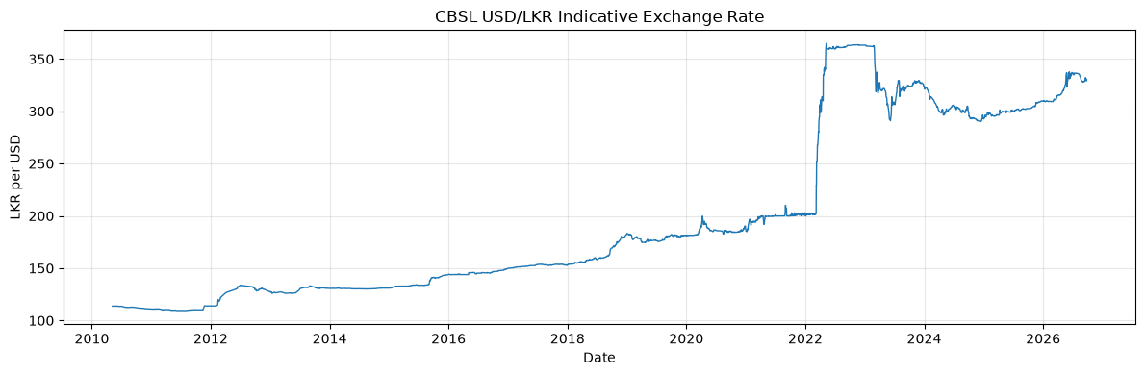
Figure 1. CBSL USD/LKR indicative exchange rate. The full history shows the long-run movement of the rate and the sharp change around 2022.

2.3 Observation-Based Returns
The log return between consecutive observations is defined as:
$r_{t} = ln\left(\frac{P_{t}}{P_{t-1}}\right)$
Because the data contains weekends, holidays, and longer source gaps, a return is a change between consecutive observations and should not automatically be described as a one-calendar-day return.

3. Exploratory and Statistical Analysis

3.1 Levels and Log Returns
The level and return panels answer different questions: the level captures long-run price movement, while returns capture proportional changes between observed rates. Most returns are close to zero, but large movements occur during unstable periods.
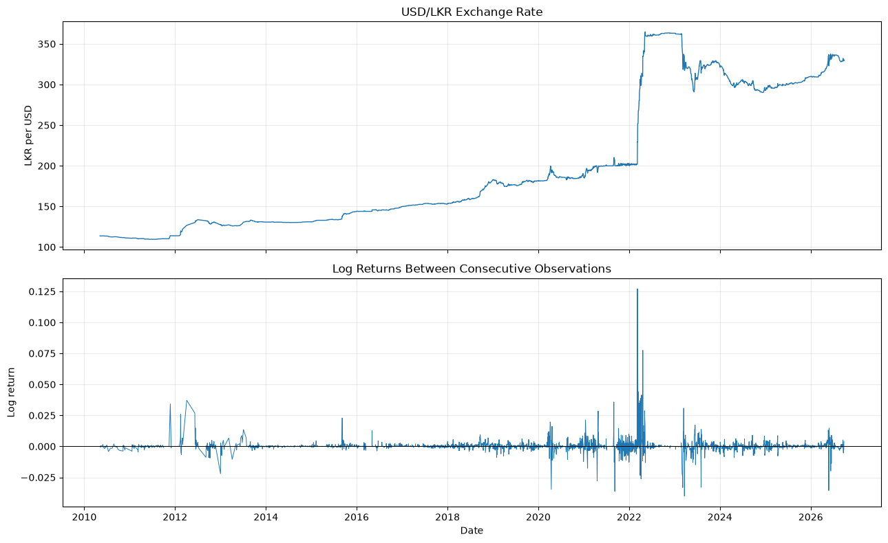
Figure 2. USD/LKR exchange rate and log returns between consecutive observations.

3.2 Return Distribution
The return sample contains 3,498 observations. Its mean is 0.000305, standard deviation is 0.004890, skewness is 8.739760, and excess kurtosis is 201.417102. The minimum is −0.040162 and the maximum is 0.127185. The Jarque–Bera statistic is 5,957,441.2456 with p-value 0, providing strong evidence against normality.
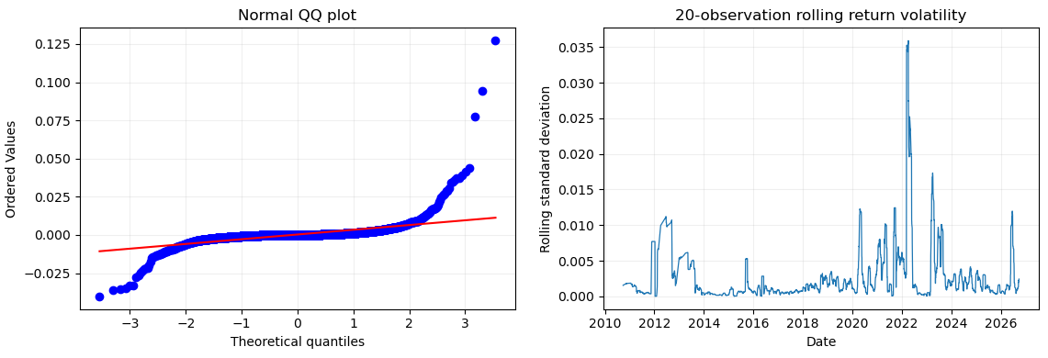
Figure 3. Normal Q-Q plot and 20-observation rolling return volatility. The Q-Q plot illustrates heavy tails compared to a normal distribution, while the rolling volatility chart highlights periods of elevated market dispersion.

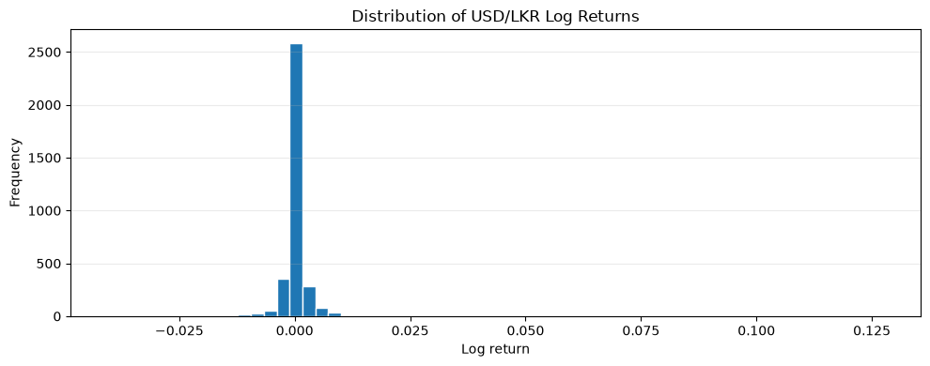
Figure 4. Distribution of USD/LKR log returns. The concentration near zero and very long tails show why large shocks can strongly affect squared-error metrics.

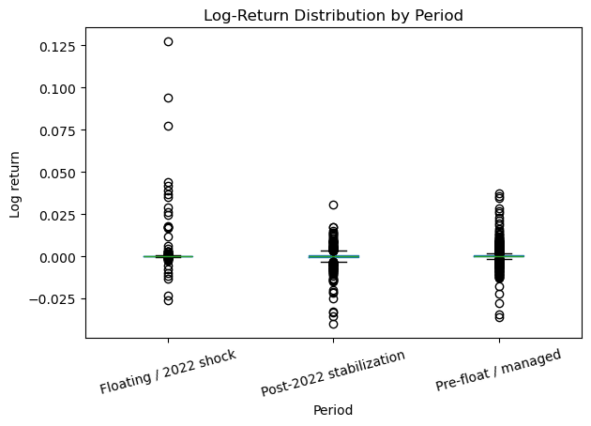
Figure 5. Log-return distribution by economic period. Return behaviour differs across the managed, floating/shock, and post-2022 stabilization periods.

3.3 Stationarity
Both the Augmented Dickey–Fuller (ADF) and KPSS tests were considered, because they have opposite null hypotheses (a unit root for ADF; stationarity for KPSS).
Table 3. Stationarity tests
Series | ADF statistic | ADF p-value | KPSS statistic | KPSS p-value | N
USD/LKR level | −0.992196 | 0.756100 | 7.980349 | 0.01 | 3,499
Log return | −8.442357 | 1.75 × 10⁻¹³ | 0.077462 | 0.10 | 3,498

The level results are consistent with non-stationarity, while the return results support stationarity. This motivates differencing for ARIMA and return-based modelling for the machine-learning and volatility analyses.

3.4 Autocorrelation and ARCH Effects
Joint serial dependence is assessed with the Ljung–Box statistic over the first m lags:
$$Q\left(m\right)=n\left(n+2\right)\sum_{k=1}^{m}{\frac{{\overset{ˆ}{ρ}}_{k}^{2}}{n-k}}$$
where ρ̂_{k} is the sample autocorrelation at lag k. Conditional heteroskedasticity is assessed with Engle's ARCH-LM test (LM = nR², from regressing squared residuals on their own lags).
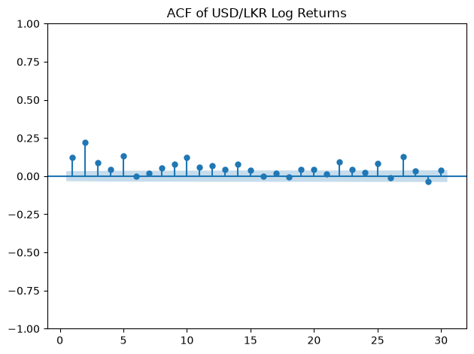 | 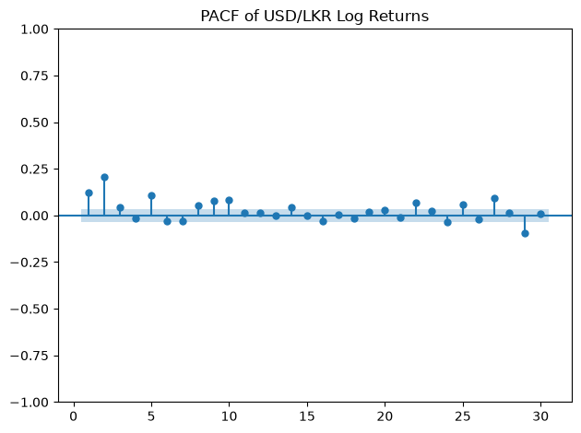
Figure 6. ACF (left) and PACF (right) of USD/LKR log returns. The plots show serial dependence at individual lags and the additional lag relationships after shorter lags are considered.
The Ljung–Box p-values are 2.47 × 10⁻⁸¹ at lag 10 and 1.91 × 10⁻⁸⁹ at lag 20, indicating joint serial dependence at the tested lags. The ARCH-LM statistic is 605.4668 with p-value 1.19 × 10⁻¹²³, and the corresponding F-test p-value is 3.93 × 10⁻¹³⁶. These results support examining conditional volatility, but they do not guarantee that a GARCH model will produce the best point forecast.

3.5 Economic Periods and the March 2022 Break
The notebooks define three analytical periods around the March 2022 move away from the managed exchange-rate regime.
Table 4. Summary statistics by economic period
Period | Obs. | Dates | Mean rate | Rate SD | Mean return | Return SD
Pre-float / managed | 2,399 | 2010-05-07 to 2022-03-08 | 154.694578 | 27.172521 | 0.000240 | 0.003094
Floating / 2022 shock | 198 | 2022-03-09 to 2022-12-30 | 350.623253 | 27.416223 | 0.002960 | 0.014723
Post-2022 stabilization | 902 | 2023-01-02 to 2026-09-25 | 312.750934 | 16.719445 | −0.000105 | 0.004269

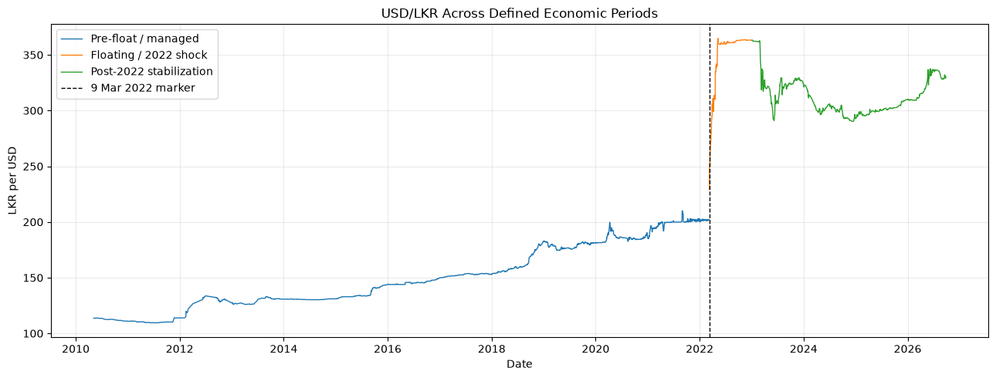
Figure 7. USD/LKR across defined economic periods. The floating/shock period is treated separately from the earlier managed phase and the later stabilization period.

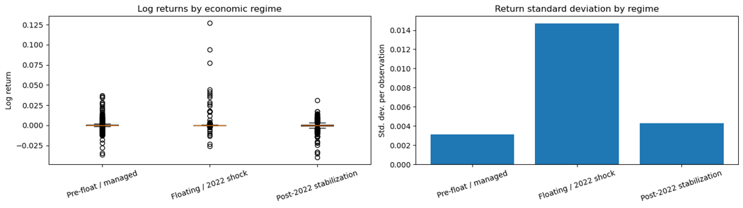
Figure 8. Log-return distribution and return standard deviation by economic period. Comparisons across the managed, floating/shock, and post-2022 stabilization periods demonstrate significant shifts in return dispersion across regimes.

A Chow-style diagnostic around 9 March 2022 compares the residual sum of squares of a pooled fit with those of separate fits before and after the break:
$F = \frac{({RSS}_{p} - {RSS}_{1} - {RSS}_{2})/k}{({RSS}_{1} + {RSS}_{2})/(n - 2k)}$ (4)
The resulting F statistic is 11,416.3745 with p-value 0. This is strong diagnostic evidence of a structural change, although the conventional test should be interpreted cautiously because the series may be serially dependent and heteroskedastic.

4. Feature Engineering
The feature-engineering notebook retains all 3,499 rows, including the latest row needed for the final live-style forecast. The engineered dataset is saved as Data/processed/feature_engineered_dataset.csv. It creates the following feature groups:

Table 5. Engineered features
Feature group | Examples | Purpose
Current state | USD_LKR, log_return | Current level and movement
Calendar-gap information | days_since_previous_obs, long_previous_gap | Account for irregular observation spacing
Level lags | Lag_1, Lag_5, Lag_20 | Observation-based persistence
Return lags | Return_Lag_1, Return_Lag_5, Return_Lag_20 | Recent movement and reversal
Rolling statistics | Rolling_Mean_5, Rolling_Mean_20, Rolling_Std_20 | Local level and dispersion
Volatility | rolling_volatility_20 | Recent return risk
Targets | Target_1, Target_5, Target_20, and return targets | Future observations for separate horizons

The feature audit confirms that no target column appears in the feature list. The expected missing values occur only at the start of lagged and rolling features and at the final row's unavailable future target. Rows whose next observation is more than five calendar days away are excluded from the primary one-step comparison, leaving 3,067 eligible observations.
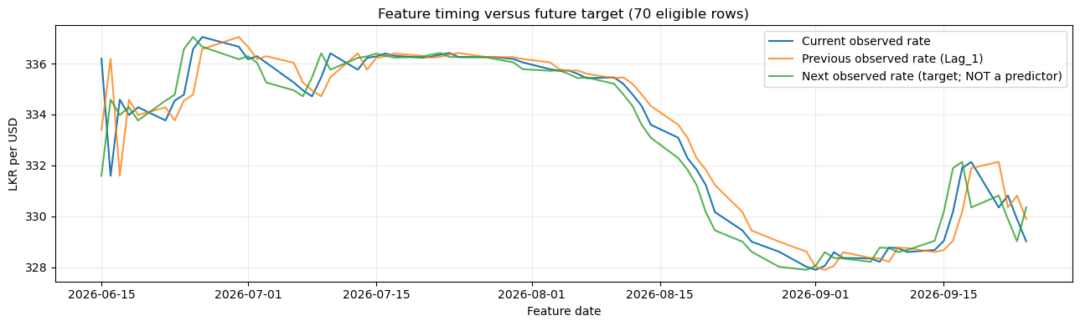
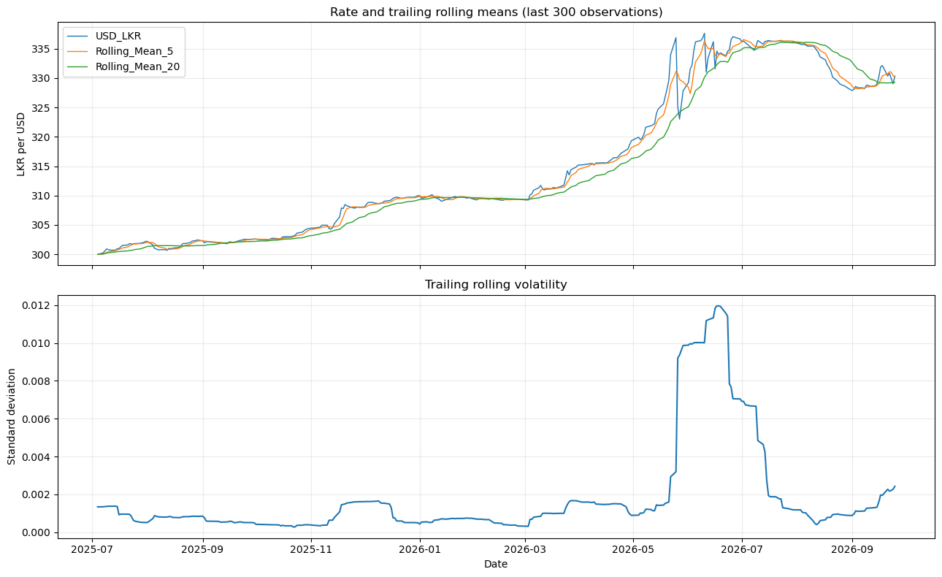
Figure 9. Feature timing alignment versus future targets and trailing rolling metrics. The top panel verifies proper temporal alignment ensuring no target leakage, while the bottom panel shows trailing moving averages and rolling volatility.

5. Forecasting Methodology

5.1 Chronological Evaluation
The eligible observations are split without random shuffling. Validation is used for model and order selection; the test set is reserved for the final comparison on common target rows. Random train/test splitting must not be substituted for this design.
Table 6. Chronological data split
Partition | Observations | Coverage
Training | 2,146 | 2014-01-01 to 2022-11-30 (target dates)
Validation | 460 | Through 2024-10-28 (target dates)
Test | 461 | Through 2026-09-25 (target dates)
Total eligible | 3,067 | From 2014 onward; next observation ≤ 5 calendar days away

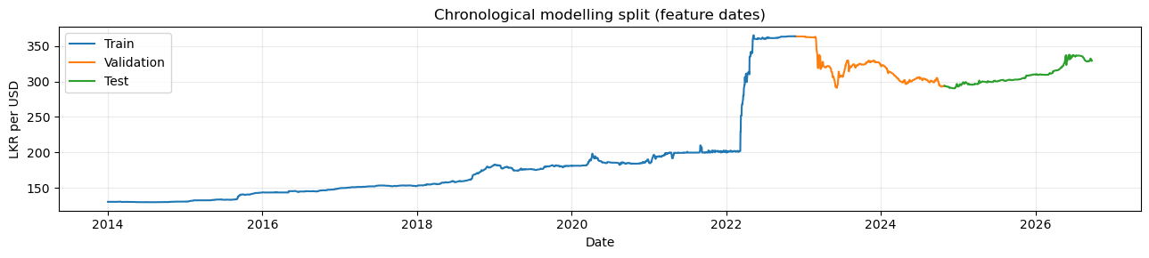
Figure 10. Chronological modelling split across feature dates. Visualizes the non-randomized partitioning into training (blue), validation (orange), and test (green) sets.

5.2 Models
Table 7. Models compared
Model | Target | Description
Naive | Next level | Carries the current rate forward; the transparent benchmark.
ARIMA | Next level | Rolling one-step level forecasts; candidate orders (0,1,0), (1,1,0), (0,1,1), and (1,1,1) compared on validation MAE.
XGBoost-return | Next log return | Predicts the return and converts it back to a rate level. Selected configuration: 300 trees, depth 3, learning rate 0.03, subsample 0.8, column subsample 0.8.
MLP-return | Next log return | Return-based neural network included as an additional machine-learning comparison.
LSTM-return | Next log return | Uses the preceding 20 observed returns to predict the next return.
GARCH(1,1) | Conditional variance | Evaluated separately with variance MSE and QLIKE, not level MAE/RMSE.

The XGBoost, MLP, and LSTM models forecast the next log return and convert it back to a rate level by applying the predicted return to the current rate. ARIMA(1,1,1) models the first-differenced exchange-rate level with one autoregressive and one moving-average term, which makes it suitable for the non-stationary level series. GARCH(1,1) models the conditional variance of returns as a function of a constant, the previous squared shock (ARCH term α), and the previous conditional variance (GARCH term β); the persistence of volatility shocks is governed by α + β.

5.3 Evaluation Metrics
Level forecasts are evaluated with MAE (mean absolute error) and RMSE (root mean squared error), where RMSE penalizes large errors more heavily. MASE is the model MAE divided by the mean absolute one-step Naive error, and relative RMSE is the model RMSE divided by the Naive RMSE; values below 1 beat the benchmark. Directional accuracy is the share of test observations for which the forecast change from the current rate has the same sign as the realized change.
Paired forecast comparisons use the Diebold–Mariano (DM) diagnostic on the loss differential between a model and the Naive benchmark; a negative statistic indicates lower loss than Naive. Volatility forecasts from GARCH are evaluated against realized squared returns using volatility MSE (the mean squared difference between realized squared returns and forecast variance) and QLIKE (a likelihood-based variance loss); lower is better for both.

6. Forecasting Results

6.1 Main Test-Set Comparison
All models are compared on the same 461 test target rows. ARIMA(1,1,1) has the lowest MAE; the Naive benchmark has the lowest RMSE.
Table 8. One-step test-set comparison (best MAE in bold)
Model | MAE | RMSE | MASE | Directional accuracy | Relative RMSE vs Naive
ARIMA(1,1,1) | 0.406721 | 0.974414 | 1.303866 | 0.620390 | 1.028479
Naive | 0.424284 | 0.947432 | 1.360170 | 0.002169 | 1.000000
XGBoost-return | 0.448500 | 1.100929 | 1.437801 | 0.611714 | 1.162013
LSTM-return | 0.511477 | 0.982958 | 1.639693 | 0.581345 | 1.037497
MLP-return | 16.035584 | 19.975001 | 51.406832 | 0.559653 | 21.083300

ARIMA reduces MAE by about 4.1% relative to Naive (0.406721 versus 0.424284), but its RMSE is about 2.8% higher (relative RMSE 1.028479). ARIMA is therefore better on typical errors, while Naive is slightly better when large errors dominate. MASE is above 1 for every model, including Naive: the scaling error implied by the table is about 0.312, and test-period errors exceed it for all models. The Naive directional accuracy (0.002169) is not informative, because a no-change forecast has no meaningful direction.
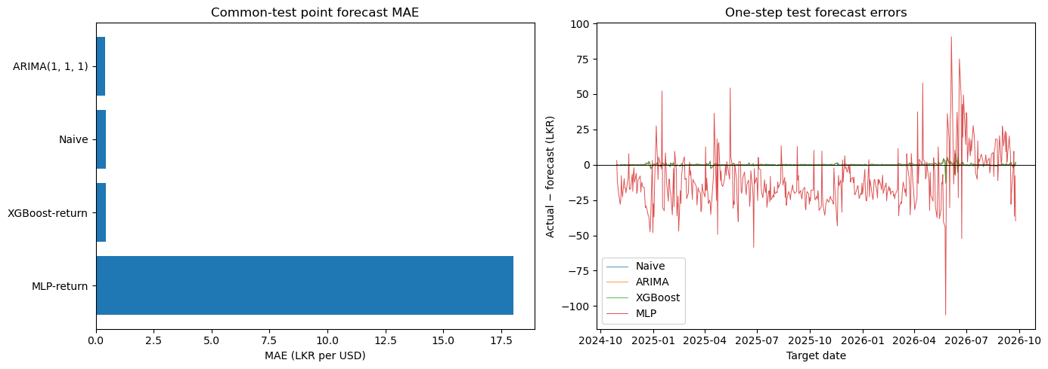
Figure 11. Common-test point forecast MAE and error distributions. Compares overall accuracy and error dispersion across evaluated models.

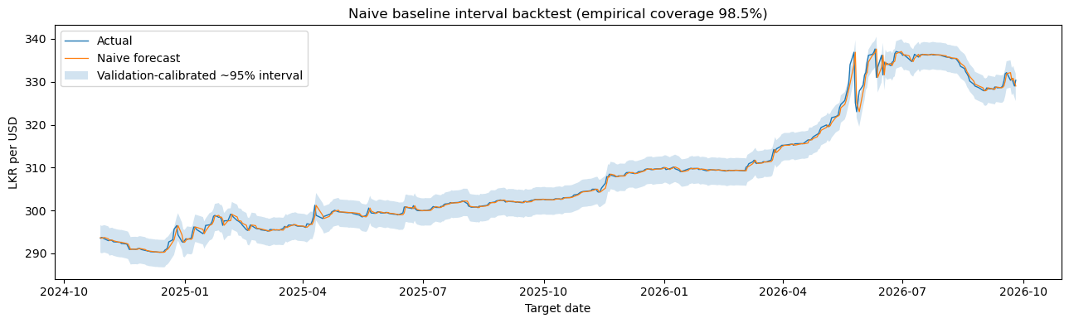
Figure 12. Naive baseline interval backtest and empirical coverage. Evaluates validation-calibrated prediction intervals around the Naive benchmark path through the test period.

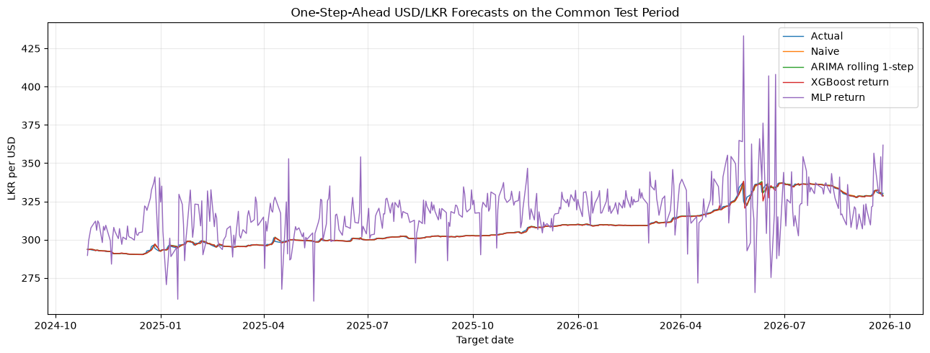
Figure 13. One-step-ahead forecasts on the common test period. ARIMA has the lowest MAE, while the Naive benchmark remains a strong reference because adjacent exchange-rate observations are often close.

The Diebold–Mariano diagnostics against Naive give DM = −2.597451 (p = 0.009392) for ARIMA, 1.240074 (p = 0.214948) for XGBoost-return, and 28.880227 (p < 0.001) for MLP-return. The ARIMA result is statistically distinguishable from Naive under this paired diagnostic, while the XGBoost difference is not significant at conventional levels. These results should still be interpreted with the limitations of one sample and one test design in mind.

6.2 GARCH Volatility Results
The estimated parameters are μ = 0.031017, ω = 0.005061, α = 0.213364, and β = 0.782614, so α + β = 0.995978, indicating highly persistent volatility. On the test period, volatility MSE is 0.411381 and QLIKE is −2.46633 (lower is better). These scores evaluate variance forecasts against realized squared returns; they must not be ranked together with level MAE or RMSE.

6.3 Feature Importance
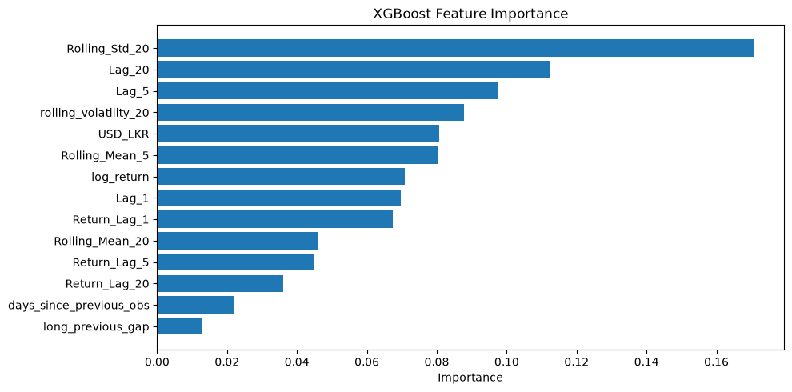
Figure 14. XGBoost feature importance. Importance is diagnostic rather than causal because many lag and rolling-level variables are highly correlated.

Rolling_Std_20 has the largest model-specific importance (0.170780), followed by Lag_20 (0.112598), Lag_5 (0.097691), and rolling_volatility_20 (0.087701).

6.4 Multi-Horizon Analysis
Horizons are measured in observations. The supplementary comparison below evaluates one-, five-, and twenty-observation-ahead targets:
Table 9. Multi-horizon comparison (Naive versus XGBoost-return)
Horizon | Model | Test obs. | MAE | RMSE
1 | Naive | 461 | 0.424284 | 0.947432
1 | XGBoost-return | 461 | 0.432352 | 1.036141
5 | Naive | 457 | 1.115646 | 1.856010
5 | XGBoost-return | 457 | 1.444756 | 2.172095
20 | Naive | 442 | 2.748674 | 4.088248
20 | XGBoost-return | 442 | 4.616474 | 6.197427

Errors increase as the forecast horizon grows, and Naive is better than XGBoost-return at all three horizons in this supplementary comparison. This supplementary analysis is a separate run, so its one-step XGBoost-return figures differ from the main comparison in Section 6.1, which remains the reference result.
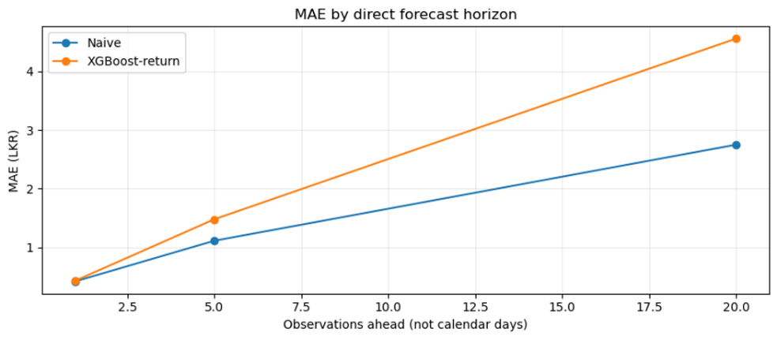
Figure 15. Mean absolute error (MAE) by direct forecast horizon. Compares the error accumulation of the Naive benchmark versus XGBoost-return across 1, 5, and 20 observation horizons.

6.5 2022 Historical Stress Test
The primary test period is recent and does not contain the March 2022 shock. A separate static-model walk-forward stress test evaluates one-step forecasts during 2022:

Table 10. 2022 walk-forward stress test
Period | Model | Obs. | MAE | RMSE
2022 walk-forward window | Naive | 239 | 1.111523 | 3.618012
2022 walk-forward window | XGBoost-return | 239 | 4.679923 | 6.154374

The shock period is substantially harder to forecast, and the Naive benchmark outperforms XGBoost-return in this stress test.

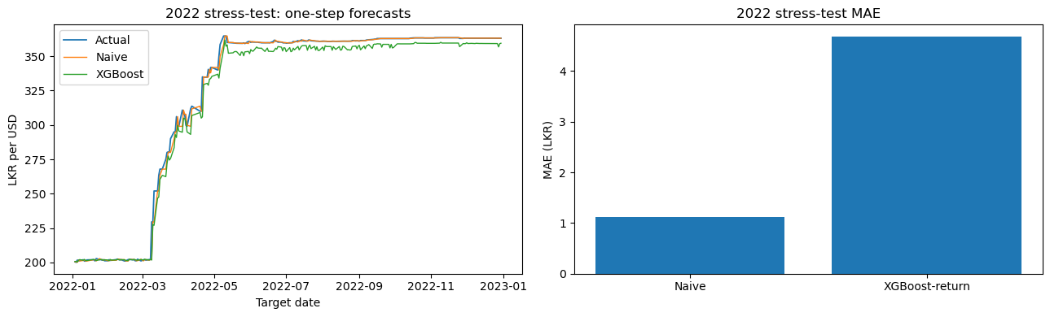
Figure 16. 2022 historical stress test forecasts and MAE comparison. Highlights model tracking performance and error magnitudes during the March 2022 exchange-rate shock window.

7. Final Forecast
Validation selects ARIMA(1,1,1), not a model chosen after inspecting the test results. Refit to the complete level series, it uses the latest available observation dated 2026-09-25, whose rate is 330.3522. The next publication date is unknown, so the forecast refers to the next observed value. Results are saved to Data/processed/final_forecast.csv.
Table 11. Final one-step forecast
Item | Value
Latest observation date | 2026-09-25
Latest observed USD/LKR | 330.3522
Selected model | ARIMA(1,1,1)
Forecast horizon | Next observed exchange-rate observation
Forecast | 330.3869
Approximate 95% prediction interval | 327.8478 to 332.9260
The forecast is 0.0347 above the latest observation, and the interval is symmetric around it (about ±2.54, or roughly 0.8% of the forecast level).
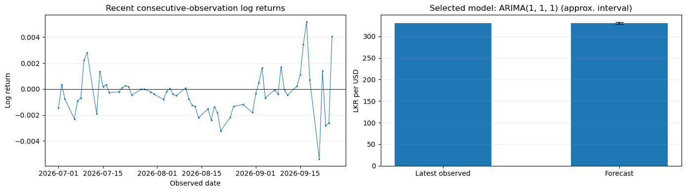
Figure 17. Recent consecutive-observation log returns and final ARIMA(1,1,1) point forecast summary. Displays recent momentum prior to the final cutoff alongside the point prediction and its approximate uncertainty bounds.
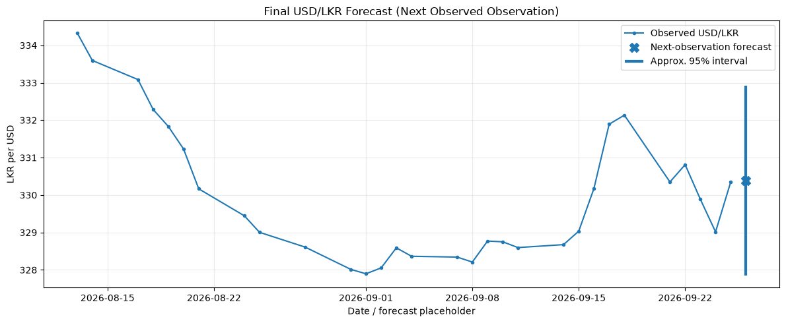
Figure 18. Final one-step forecast and approximate prediction interval. The forecast is shown at a labelled placeholder after the latest observation because the next publication date is not known.

The interval is an approximate model-based interval and is not a guarantee. It may under-cover during policy changes, liquidity shocks, or other structural breaks.

8. Discussion
ARIMA is the best point-forecast model by MAE under the corrected validation and common-test design, but the Naive benchmark remains competitive and has the lowest RMSE among the listed models. This is consistent with short-run persistence: the latest exchange-rate level contains substantial information about the next observed level. XGBoost-return and LSTM-return add nonlinear or sequential capacity, but capacity does not create information about unexpected policy or market shocks. MLP-return is unstable in this configuration and has much larger errors.
The March 2022 break is central to interpretation. The floating/shock period has a much higher mean return and return standard deviation than the managed and post-2022 periods. A model calibrated in one regime may not transfer reliably to another, and the 2022 stress test confirms that crisis forecasting is materially more difficult.
GARCH remains useful even though it is not a competing level model. The ARCH-LM result supports conditional-volatility modelling, the estimated persistence (α + β ≈ 0.996) indicates that volatility shocks decay slowly, and the GARCH output provides a risk estimate that a point forecast alone cannot provide. A practical treasury system could therefore combine an ARIMA or Naive point forecast with a volatility forecast and external macroeconomic information.

9. Limitations
- The analysis uses one univariate exchange-rate series and does not include interest rates, inflation, reserves, trade flows, political events, intervention data, or international market variables.
- The data is an indicative published rate and should not automatically be interpreted as an executable market quote.
- Irregular observation gaps mean that an observation-based return may span several calendar days.
- The five-day eligibility rule improves comparability but removes long-gap targets from the primary comparison.
- Results depend on the selected chronological split, feature definitions, hyperparameters, and software environment.
- The LSTM result depends on optional TensorFlow availability and training behaviour.
- A single historical test period cannot establish universal model superiority.
- Prediction intervals are approximate and may under-cover during structural breaks.
- Level MAE/RMSE, directional accuracy, volatility MSE, and QLIKE answer different questions and should not be combined into one ranking.

10. Conclusion
This study compared traditional time-series and machine-learning models for USD/LKR exchange-rate forecasting. ARIMA(1,1,1) achieved the lowest MAE (0.406721) and the highest directional accuracy (62.04%), while the Naive baseline achieved the lowest RMSE (0.947432). These results support ARIMA as the preferred model for reducing average forecast errors and capturing exchange-rate direction, although its performance is not superior across every metric. The selected ARIMA model forecasts the next observed exchange rate at 330.3869, with an approximate 95% prediction interval of 327.8478–332.9260. Overall, the findings highlight the importance of fair model comparison and accounting for economic regime changes when forecasting exchange rates.

11. Reproduction Guide

11.1 Notebook Guide
Table 12. Notebook guide
Notebook | Purpose
01_data_collection.ipynb | Filters the raw file, checks quality and observation gaps, and saves the cleaned series.
02_eda_and_statistics.ipynb | Creates returns, evaluates distributions and stationarity, tests dependence and ARCH effects, and compares economic periods.
03_feature_engineering.ipynb | Creates lag, rolling, calendar-gap, and one-, five-, and twenty-observation target features.
04_model_develpoment_and_forecasting.ipynb | Performs chronological validation, evaluates models, generates diagnostics, evaluates volatility, and runs supplementary analyses.
05_final_prediction.ipynb | Refits the validation-selected model on all observations and writes the final forecast record.

11.2 Steps to Reproduce
- Open the repository in Jupyter Notebook, JupyterLab, or VS Code.
- Run the notebooks in numerical order.
- Confirm that the working directory and relative paths point to the repository root.
- Review the generated files in Data/processed/ and the figures in figures_new/.
- Read the full report in Formatted_Project_Report_Updated.docx or the source report in Project_Report.md.
The repository follows the layout Data/ (raw and processed), figures_new/, notebooks/, Project_Report.md, and README.md; the report figures come from figures_new/. The modelling evaluation uses chronological splits only; random train/test splitting should not be substituted for the documented workflow.
Git-Hub Repository Link: https://github.com/mitharamallikaarachchi/USD-LKR-Forecasting

12. Summary

Research Task | Forecasting the next published USD/LKR indicative exchange-rate observation
Data Source | Central Bank of Sri Lanka (CBSL), indicative rate
Sample | 3,499 observations, 7 May 2010 to 25 September 2026
Models Compared | Naive, ARIMA, XGBoost, MLP, LSTM, GARCH(1,1)
Selected Model | ARIMA(1,1,1), chosen on validation MAE

